Problem Statement: Create an S3 bucket, with no public access and upload files to the bucket & view the logs for the uploaded files. Launch two ec2-instances and connect it to an application load balancer, where the output traffic from the server must be an load balancer IP address

Part 1:

Create a S3 bucket, with no public access and upload files to the bucket & view the logs for the uploaded files.

Go to S3 🡪 Create a bucket by clicking “Create bucket” 🡪 Provide the name and select the configurations

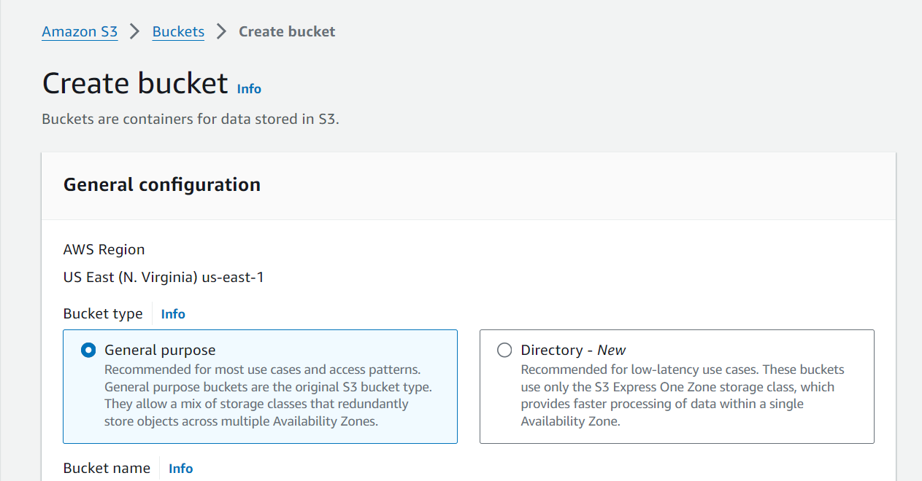

Since the ask is to create a bucket with no public access,

Check the box named “Block all public access” 🡪 Click on Create Bucket

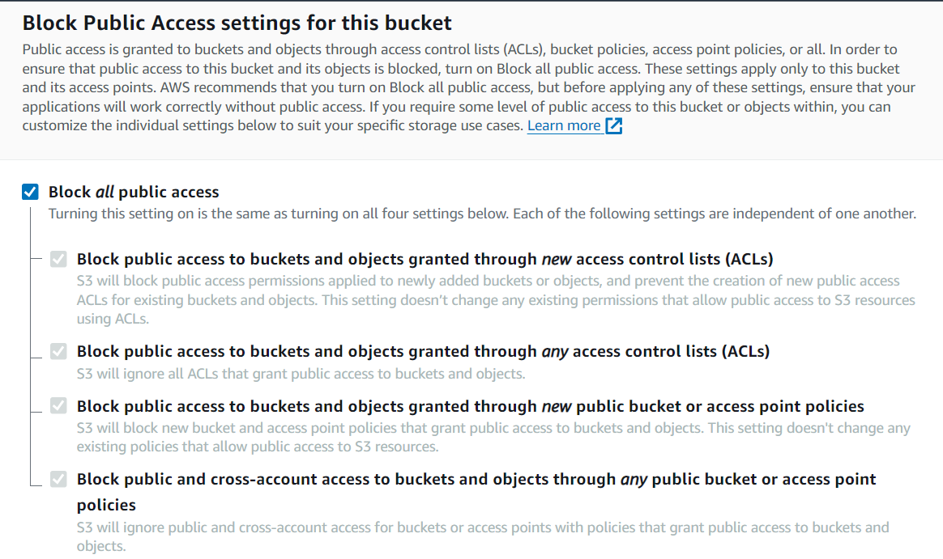

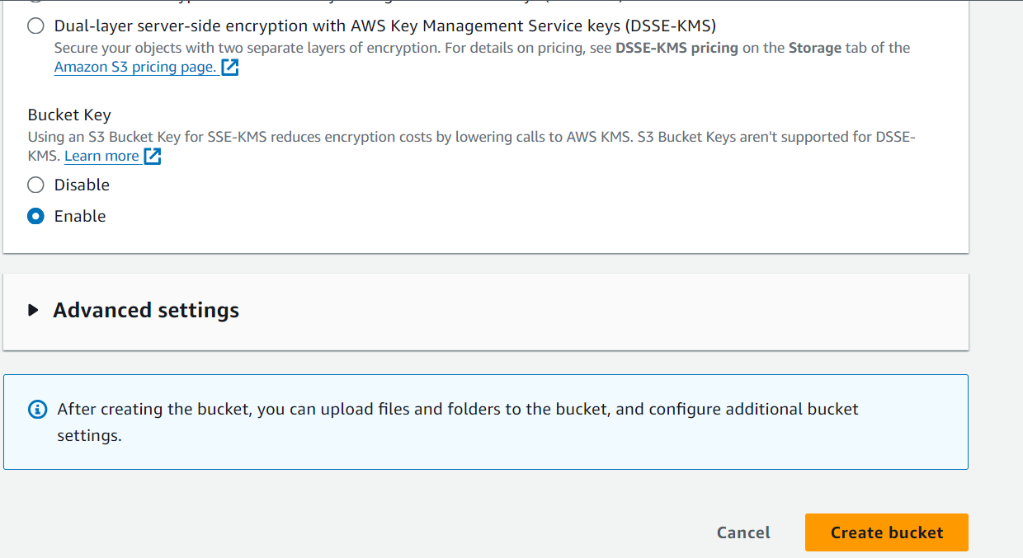

After creating the bucket go to the Properties section of the bucket,

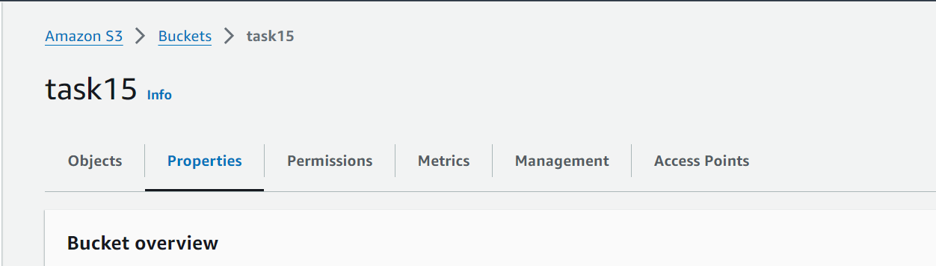

Under the properties section, enable the Server access logging option by editing the section

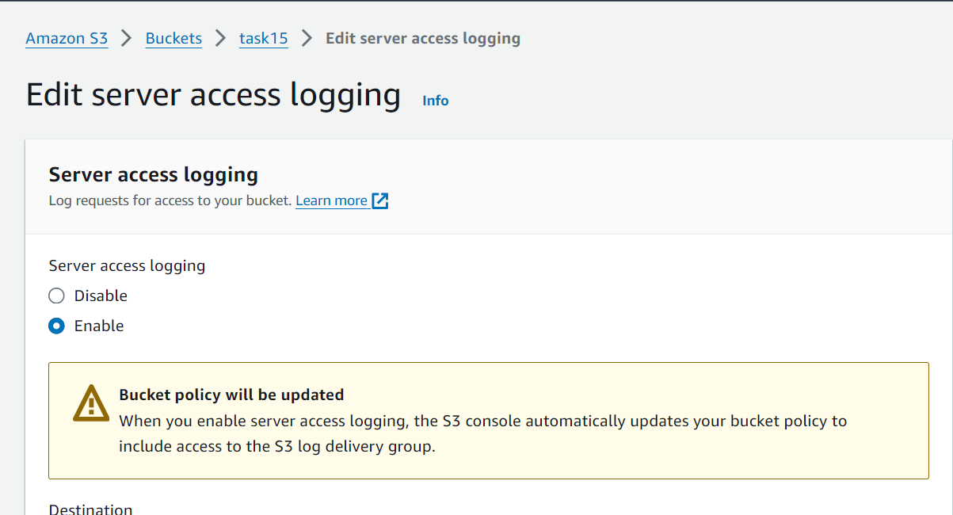

After enabling fill the details like Destination in which the log file has to be stored, and also select the log object key format as well and save the changes.

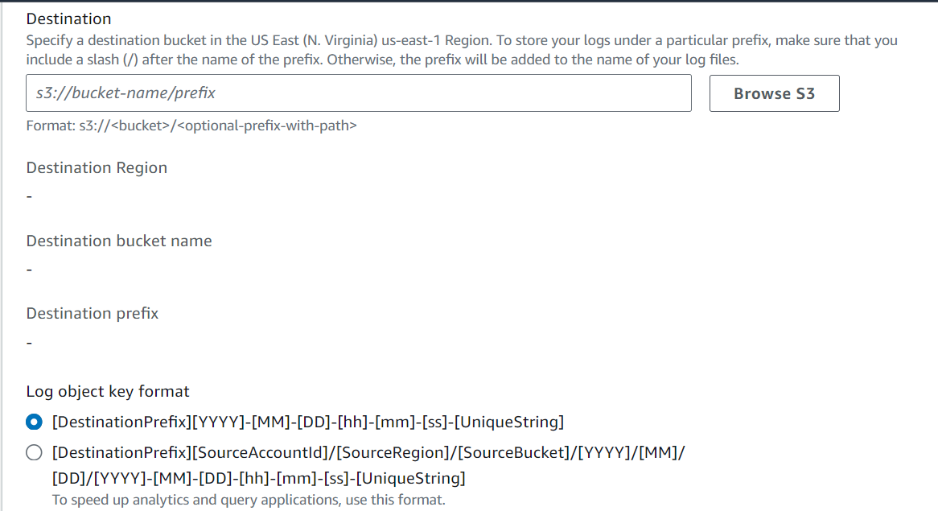

Log will be created in the destination folder per minute as below,

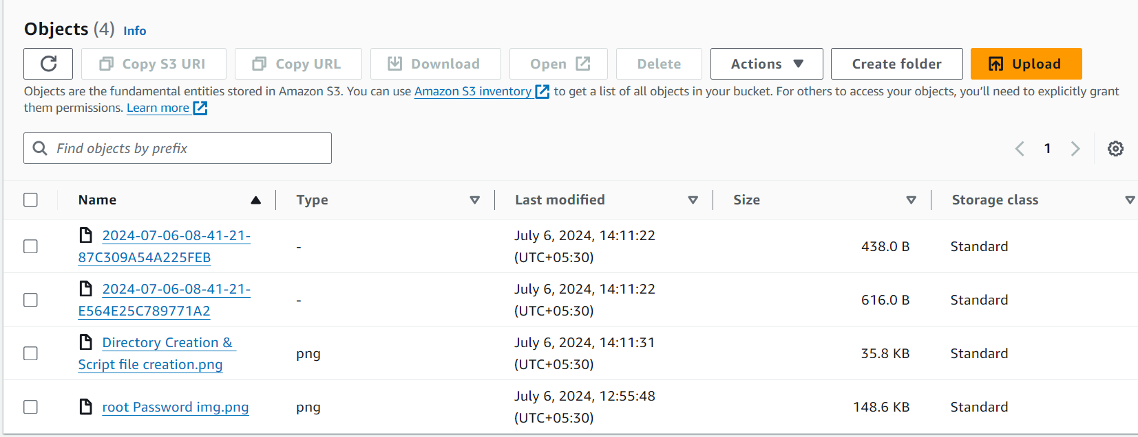

Part 2:

Launch two ec2-instances and connect it to an application load balancer, where the output traffic from the server must be an load balancer IP address

Launch 2 EC2 instances, with the same security group but a new one

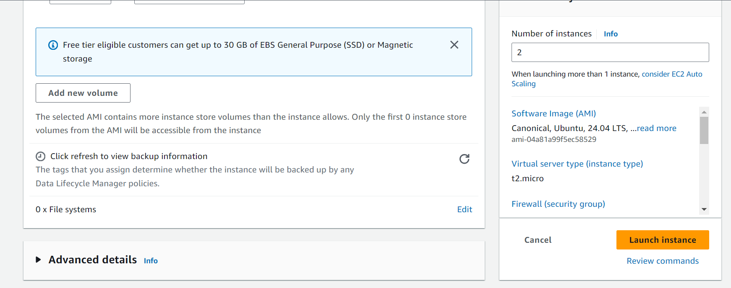



Now create a load balancer, of application load balancer type,

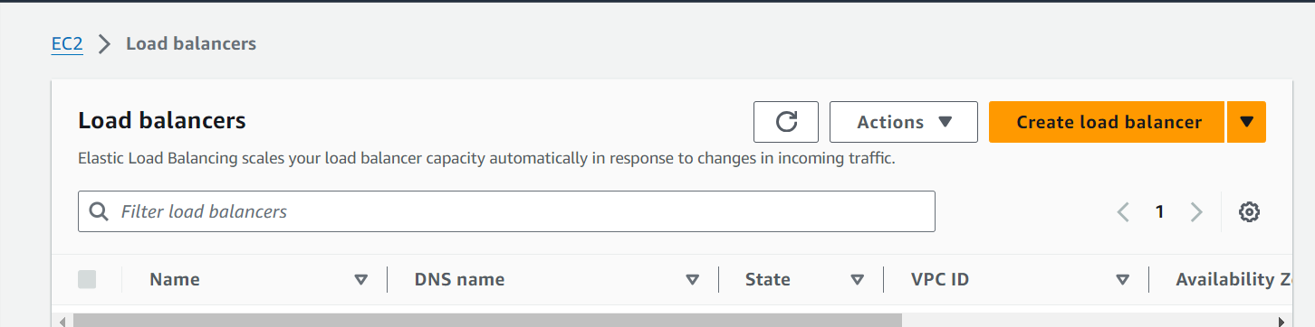

Create a new Security group,

Allow the Inbound rules, with port 80, HTTP request alone,

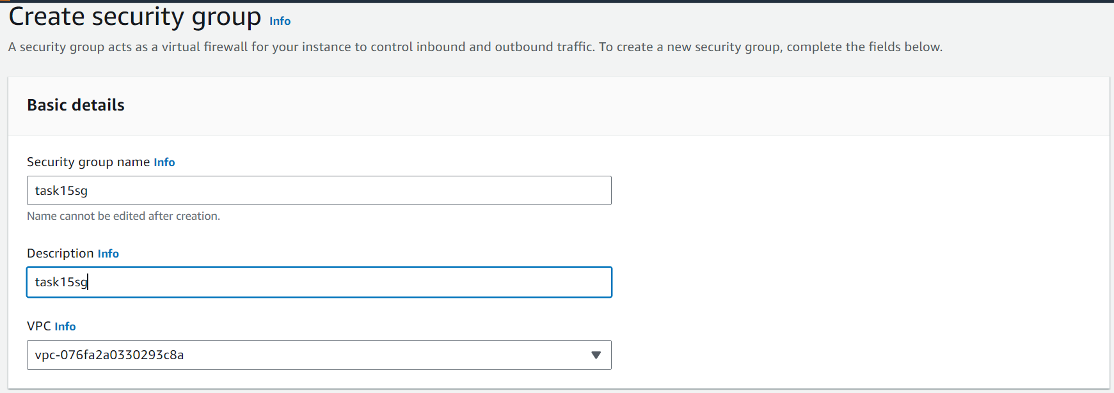

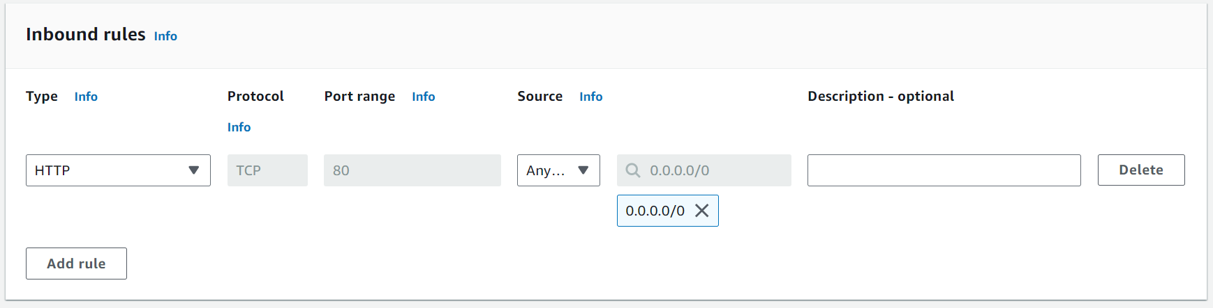

Create a Target group and select the 2 instances created,

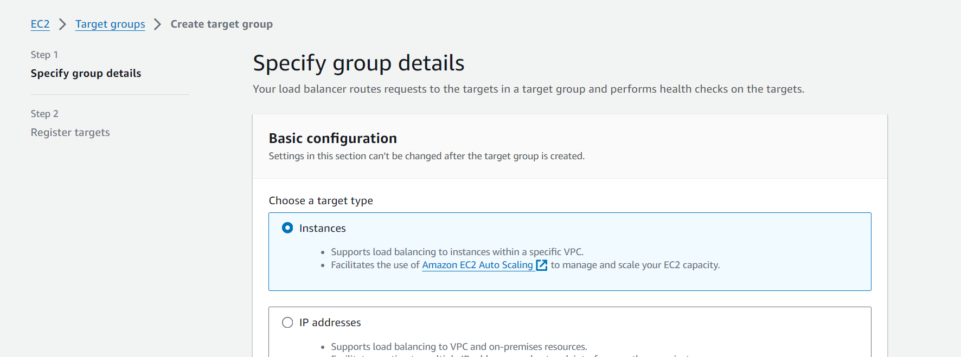

Select the 2 instances as above, and save the settings

Select the created Target group while configuring the Load balancer,

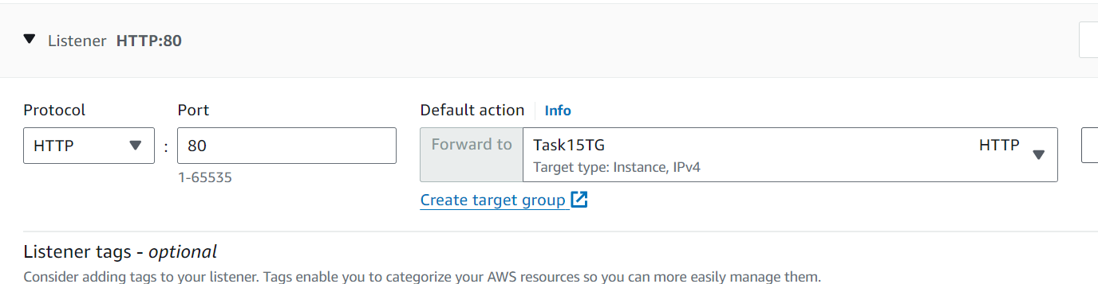

Now, we need to configure the Security group in such a way that the outbound traffic is directed to the load balancer,

Go to the Security group of the 2 EC2 instance 🡪 Go to Outbound rules 🡪 Delete the existing Outbound rules 🡪 Add the outbound rule in such a way that the security group which is mapped with the load balancer is selected for all traffic

